

SIMICOLE 2002-t
Short manual for contents edition

Last updated: 10/03/04

To login as Administrator: (to compile contents)
user: "..." (that is, do not select any user)
password: "administ"

Course contents organisation:
Contents should be placed in folder X:\LEECOM\SIMIC02\Contenid\ where X:\ is any local drive or remote network drive existing in “Mi PC”. For example, D:\ for the CDROM. This will work for any drive in the computer (including A:\) as long as the folder path is as shown before.

It is recommended that the new contents are placed in the following path: C:\LEECOM\SIMIC02\Contenid\

SIMICOLE 2002-t installs a small set of contents in the previous path consisting in two fictitious training units in English with some instructions for the generation of new contents.

The folder structure is shown in next image:

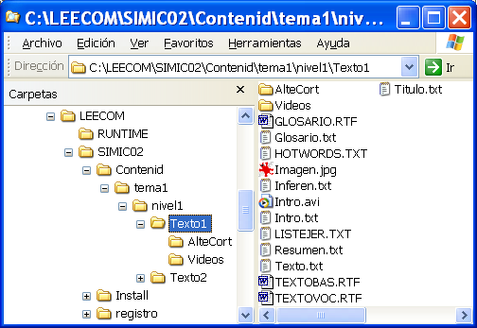

It is recommended to work initially with training units in just one topic or tema (/tema1) and one level (/nivel1).

Files needed in folder /Contenid
- TexNiv1.txt: Listing of units for level 1 in the order that will be shown to the student. See next section of this manual.
- TexNiv2.txt: as before for level 2. The unit folders (texto1, texto2, texto3…) for this level must be placed in folder /nivel2. The file can be empty but it must exist.
- TexNiv3.txt: as before for level 3.
- CD1.id. CD2.id, CD3.id. Empty files that indicate that this folder contains the content units for levels 1, 2 and 3.
- Lang.txt: contains the words and sentences that appear in current SIMICOLE interface. For example, the text for each button is extracted from this file.Initially this is English but there are other language configurations stored that can be activated stored in lang-de.txt, lang-en.txt, lang-es.bat, lang-val.bat…).
- _Spanish.bat, _English.bat, _German.bat, _Valencia.bat… When any of these files is run from the Windows Explorer, the file lang.txt is updated to the selected language. You must close and reopen SIMICOLE to see the changes appear in the interface.
- Version.txt: contains the text to be shown in the “CD Content:” in the start page.
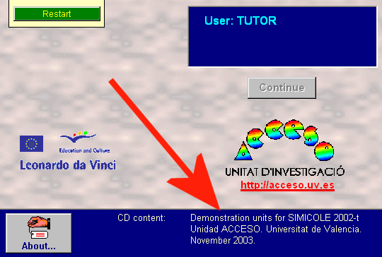

Format of file TextNivN.txt in folder /Contenid

The format for each line of TexNivN.txt are two numbers that represent <TemaT>”,”<TextoX>.

Each line of the file references the unit that will be shown and whose contents must be in the following folder: \Contenid\TemaT\NivelN\TextoX

Example of TexNiv1.txt:
1,1
1,2
1,3
2,1
2,2
3,1
3,2
6,1
7,1

In this case the program would show the units to the student in the following order for level 1:

- \Contenid\Tema1\Nivel1\Texto1
- \Contenid\Tema1\Nivel1\Texto2
- \Contenid\Tema1\Nivel1\Texto3
- \Contenid\Tema2\Nivel1\Texto1
- \Contenid\Tema2\Nivel1\Texto2
- \Contenid\Tema3\Nivel1\Texto1
- and so on….

Files in each folder /TemaN
- Titulo.txt: Title for this topic in a single line. (optional, as it will not be shown anywhere in SIMICOLE 2002-t)

N goes from 1 up to a maximum of 19 and there must not any intermediate number missing.

If there are less than 9 units per level it is recommended to use a single folder named /Tema1 in the whole SIMICOLE.

Files in each folder /TextoN
N goes from 1 up to 9, so there can be a maximum of 9 units per level (nivel) and topic (tema).

Files to be created manually:
- Glosario.txt: vocabulary of difficult word and sentences with associated definition
- Intro.txt: Text of introduction for this unit
- Texto.txt: Text for the unit (see section on format later on)
- Titulo.txt: Title of this unit in a single line.
- Resumen.txt: text to be shown in the summary exercise (first production exercise). One single paragraph. Do not use character “;”
- Inferen.txt: text to be shown in the inference exercise (second production exercise). One single paragraph. Do not use character “;”
- Imagen.jpg: image associated to the unit in jpg format. Maximum dimensions: 500 pixels width and 400 pixels height. Optional (it may not exist).
- Intro.avi. Introduction recorded in signed language. Optional (it may not exist).
Approximated size: width 180 pixels and height 200 pixels. It is recommended to use the basic codecs already installed in Windows like CinePak Codec.

Files created automatically after doing [Compile Contents] > [Texts and Glossaries]
- HOTWORDS.TXT
- GLOSARIO.RTF
- TEXTOBAS.RTF
- TEXTOVOC.RTF

Files created automatically after doing [Compile Contents] > [Exercises]
- LISTEJER.TXT

Subfolders in each folder /TextoN:
- Videos: contains the sign language videos for the vocabulary definitions
- AlteCort: contains SIMICOLE automatically markable exercises

Files in each folder /AlteCort:
- EjerciN.txt contents for each exercise of automatic marking up to a maximum N of 99.
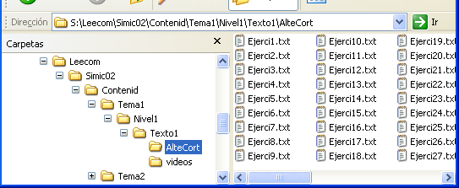

Files in each folder /Videos:
- AVI files of vocabulary. Optional. There may be one or more glossary terms without associated video.
- Videos.txt. Contains the equivalence between the term mentioned in Glosario.txt and the corresponding AVI file. The name of the AVI file can have a maximum of 8 letters.

Example:
clubs: clubs
fundations: fundatio
regulations: regul
according to the law: acc_law

In this case the videos in folder /Videos should be:
- clubs.avi
- fundatio.avi
- regul.avi
- acc_law.avi

Format of files Intro.txt y Texto.txt in each folder TextoN

In the texts shown in screen for the introduction and main text the indenting of first line will appear automatically.

Leave a blank line between paragraphs to facilitate reading on the screen.

Paragraphs should be continuous, without break lines. If editing is done in Windows XP with NotePad, this can be checked activating and deactivating the option [Word Wrap] from the [Format] menu.

Important.

After creating or modifiying texto.txt or glosario.txt it must be run the option [Compilar Contents] > [Texts and Glossaries] from Administrator Mode menu.

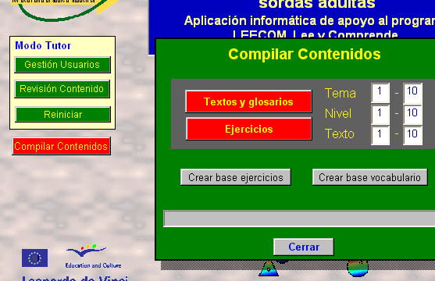

If new units are created, do not forget to update also the file TextNivN.txt with the new references.

Format of file Texto.txt

Vocabulary terms (hotwords) should be marked like this: “_fundaciones_”.
Character “_” will be hidden automatically. Example:

El campeón _olímpico_, seleccionado cuidadosamente y entrenado durante años para mejorar sus _marcas_, es, sin duda, un deportista. Pero también lo es el estudiante que _consagra_ su tiempo libre a disputar partidos de fútbol, o el oficinista que se ejercita para mantenerse en forma varias horas a la semana en las _pistas_ del _estadio_.

A pesar de su relativa...

Result from previous example once it has been compiled in SIMICOLE:

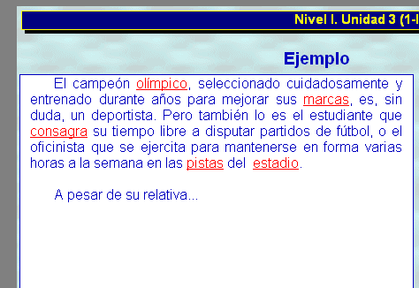

Expressions with several words can also be used. For example: ”_according to the law_”.

Format of file Glosario.txt

Follow exactly the estructure of the following example.

Example:
olímpico: deportista que ha participado en alguna olimpiada.
marcas: resultados técnicos obtenidos por un deportista.
consagra: se dedica con especial atención a un determinado fin.
pistas: camino o espacio por el que corren los deportistas.
estadio: conjunto de instalaciones con filas de asientos para los espectadores, destinado a competiciones deportivas.

The term before “:” must correspond exactly with the term between characters “_” in Texto.txt.

After character “:” there must be only one blank space before the text of the definition.

Format of exercise files EjerciN.txt

- The first line must always be “1-1”. Exercises will be shown to the student in the order indicated by the number N of the file (up to a maximum of 99).
Example: ejerci4.txt referes to the 4th exercise of this unit. It is necessary that all preceding exercise files also exist, in this case: ejerci1.txt, ejerci2.txt and ejerci3.txt.
- The second line is the code of Bloque + Área + Objetivo + Tipo de Actividad in format BAA-OOTT:
  - B: Main objective set (bloque) 1, 2 or 3. Depending on this parameter the corresponding element on the exercises screen will be highlighted for the student: Vocabulary, Sentences or Understand.
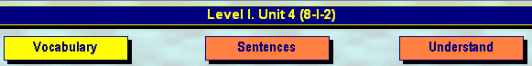
  - AA: área 01, 02, 03... In case of doubt it can be set as 99.
  - OO: objetivo: 01, 02, 03... In case of doubt it can be set as 99.
  - TT: tipo de actividad: 01, 02, 03... In case of doubt it can be set as 99.
(see annex in Spanish about “Lista de bloques, áreas y objetivos” in LEECOM: Programa de Instrucción de la Comprensión Lectora para Personas Sordas)

- The following lines in the file must start with character "#".
- The 3rd line is the main heading of the exercise that will appear in red to the student.
- La 4th line is the exercise subheading and will appear in blue below the main heading.
- La 5th line is the correct option for the exercise.
- Lines 6th, 7th and 8th area the three other (incorrect) options that will be shown to the student.

The program will alter the order of the four possible options before showing them to the student.

Important.

After creating of modifying the exercise files it must executed the option [Compile Contents] > [Ejercises] from Administrador Mode menu.

Example of Ejerci2.txt:
1-1
301-0102
#Selecciona la respuesta correcta:
#En relación con la idea principal del texto, ¿qué idea NO es importante?:
#En tus bolsillos caben muchas cosas.
#Es muy importante reciclar el papel.
#Hay que utilizar los transportes públicos.
#Reglas para cuidar el medio ambiente.

This would be the 2nd exercise of the unit. It referes to bloque 3, área 01, objetivo 01 and tipo de actividad 02 (301-0102).

It would be shown like this in SIMICOLE 2002-t:

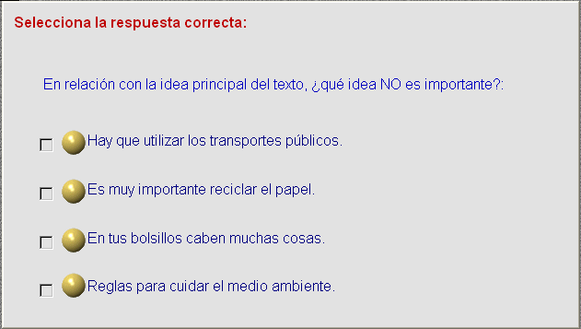
The element highlighted on top would be the third one (Understand):

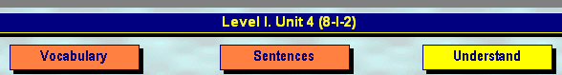

More information
For more and updated information visit: http://acceso.uv.es/mas/simicole/

